**PLMViewer – Environmental setup documentation**

**January 28, 2016**

**Version: 1.0**

# Configure Maven

1. Download the Maven’s zip file, and Unzip it to the directory you wish to install, and configure the Windows environment variables.
2. Create a User variable with Name M2_HOME and set the Maven installation path in User Variable List (Eg: M2_HOME= E:\Raveen\Middleware-PLM EOL\Source\apache-maven-3.2.5)

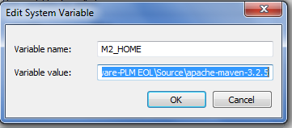

1. Create a User variable with Name M2 and set maven EXE path in User Variable List (Eg: M2=%M2_HOME%\bin)

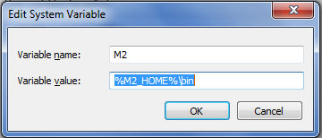

1. Create a User variable with Name MARN_OPT and set the VM parameters (Eg: MAVEN_OPTS=-Xms256m -Xmx512m )

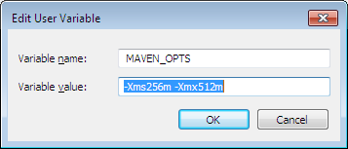

1. Append the Maven exe Path in System Variable

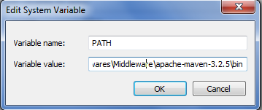

# Environmental variables

1. Right click my computer and select properties
2. Click Advance System Settings and select the Advanced Tab
3. Click the Environmental variable Button and the click New in User Variable List to add the JAVA_HOME Variable
4. Enter the java Installation path then click OK

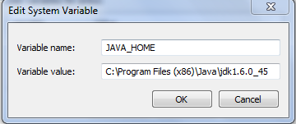

1. Select the Path Variable in the System Variable list and Click Edit
2. Go the the End and add the java exe path (eg: C:\Program Files (x86)\Java\jdk1.6.0_45)

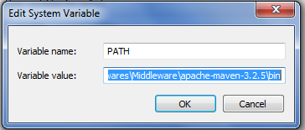

1. Restart the System and go the commad promt and type
2. ( javac ,mvn –version) to confirm the installation Is proper

# Github Plug-in and code configuration:

Check for LifeRay IDE plug-in in eclipse using Help -> About Eclipse

1. EGIT plug-in for eclipse from the below path

[**http://download.eclipse.org/egit/updates**](http://download.eclipse.org/egit/updates)/

For older versions use the site below

<http://wiki.eclipse.org/EGit/FAQ#Where_can_I_find_older_releases_of_EGit.3F>

1. Help>>Install new Software>>Add. And select the path of the plugin where you have downloaded the plugin or get it directly online.

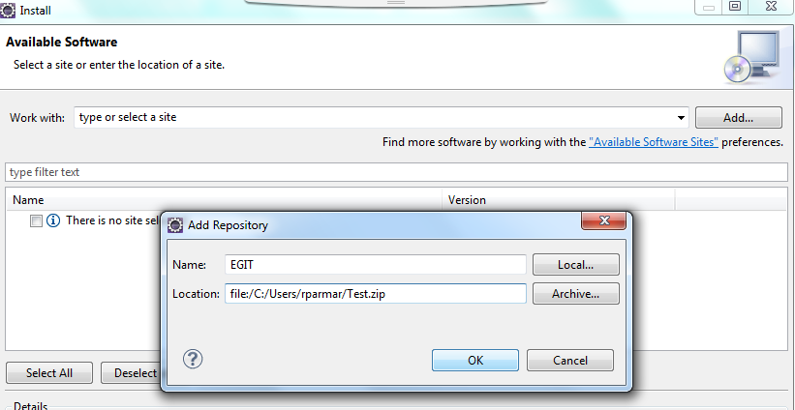

1. Select the TFS plugin

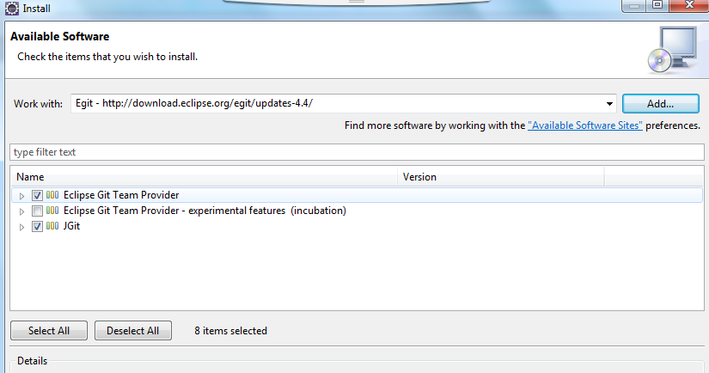

Import the project from GIT:

1. Create new workspace and import the project from GITHub

Project >Import >Git >Projects From Git and hit Next

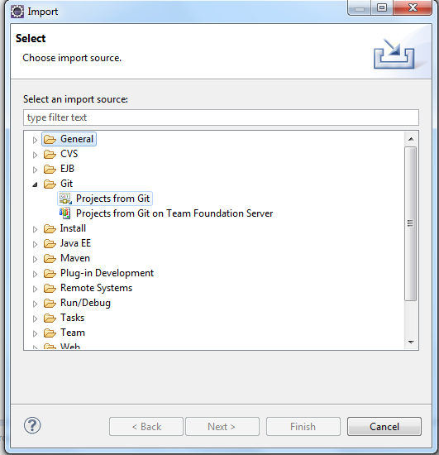

1. Select the URI to get prjojects ( Please make sure you have created a Fork of aicGit/PLMViwer repo for yourself)

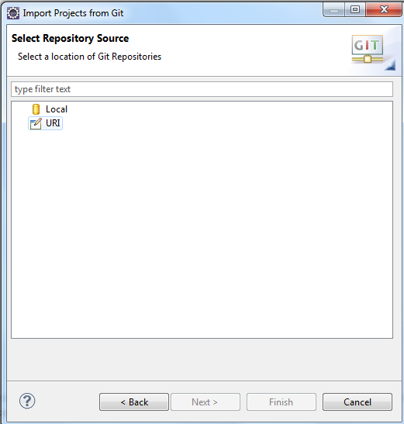

1. Add the url for you fork in Git hub, Enter you credentials and hit next

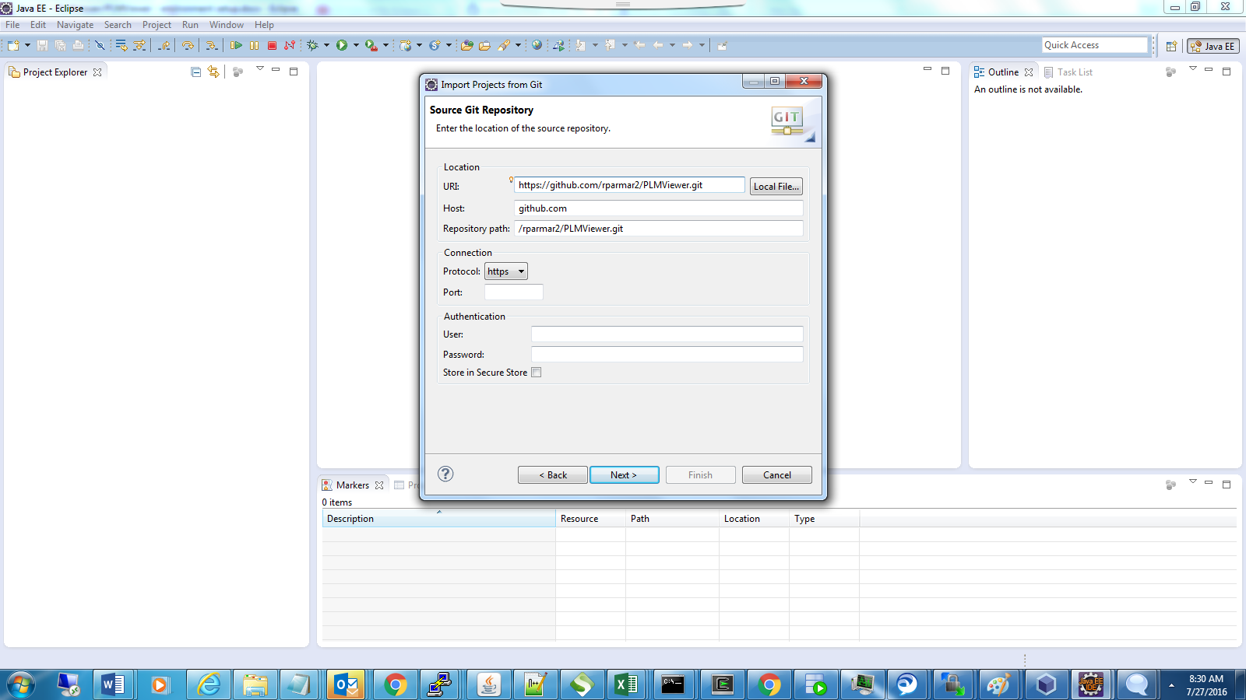

1. Connect to the server using the coach credentials
2. Click Finish to import

# Build steps

* Get Latest code from Github
* Run command ‘mvn clean install package’ in run configuration
* Navigate to target folder
* Copy the PLMViewer.War and move it to the #Tomcat Server/ Webapp /PLMViewer.war
* Restart the Server
* Access the Application through http://<hostname>:<port>/PLMViewer

# Server Configuration

* Download Apache Tomcat Server 8.0
* Configure the Default java_home ,Port settings
* To Access resources outside from Server Add the Following Entries in Server.xml

<Context path="/LCSWDoc" docBase="/cwedev/apps/pmdb/docs/content" reloadable="true">

</Context>

<Context path="/LCSWImages" docBase="/cwedev/apps/pmdb/docs/content" reloadable="true">

</Context>